**Department of Electronics and Telecommunication Engineering**

**PART-A (About 2-3 Pages)**

**Format for Micro-Project Proposal**

**For 1st to 4th Semester**

**Title of Micro Project: DTMF Decoder**

**1.0 Brief Introduction: (Importance of the Project, in about 4 to 5 sentences)**

The HT9170B/D are Dual Tone Multi Frequency (DTMF) receivers integrated with digital decoder and bandsplit filter functions as well as power-down mode and inhibit mode operations. Such devices use digital counting techniques to detect and decode all the 16 DTMF tone pairs into a 4-bit code output. Highly accurate switched capacitor filters are implemented to divide tone signals into low and high group signals. A built-in dial tone rejection circuit is provided to eliminate the need for pre-filtering.DTMF keypad is placed out on a 4 cross 4 matrices, in which each row represents low frequency, each column represents high frequency, with DTMF, each key passed on a phone generates  two tones of the specific frequencies one tone is generated from a high frequency tones and low frequency tone. These tones are converted to digital form using DTMF decoder circuit. These codes are the address of the destination which is read and preceded by the computer that connects the caller to the destination. The DTMF decoder circuit used in many [electronics projects](http://www.edgefxkits.com/electronics-projects) for better connectivity to control the applications.

**2.0 Aim of the Micro Project (in about 4 to 5 sentences)**

In earlier days, our telephone systems were operated by manually in a telephone exchange room. The callers will pick up the phone and giving instruction to the operator to connect their destination line. The DTMF technology provides ultimate solutions for the telephone industries which is used to switch two lines automatically. The DTMF stands for ‘Dual Tone Multi-frequency’ which is one of the techniques for converting the analogue signal to digital using DTMF decoder. The DTMF decoder circuit mostly used in mobile communications system which recognizes the sequence of DTMF tones from the standard keypad of the mobile phone.

**3.0 Action Plan (Sequence and time required for major activities for 8 weeks)**

|  |  |  |  |  |
| --- | --- | --- | --- | --- |
| **Sr.** | **Details of Activity** | **Planned** | **Planned** | **Name of Responsible** |
| **No.** |  | **Start Date** | **Finish Date** | **Team Members** |
| 1 | Presentation on topic | 25/6/20 | 25/6/20 | Sania Bandekar |
| 2 | Drawing circuit diagram | 27/6/20 | 29/6/20 | Sania Bandekar |
|  |  |  |  |  |
| 3 | Designing PCB | 30/6/20 | 30/6/20 | Sania Bandekar |
| 4 | Developing the chassis and soldering board | 27/7/20 | 30/7/20 | Sania Bandekar |
| 5 | Final submission | 27/8/20 | 30/9/20 | Sania Bandekar |
|  |  |  |  |  |

**4.0 Resources Required (Such as raw material, some machining facility, software etc.)**

|  |  |  |  |  |
| --- | --- | --- | --- | --- |
| **Sr.** | **Name of Resource/Material** | **Specifications** | **Qty** | **Remarks** |
| **No.** |  |  |  |  |
| 1 | Crystal oscillator | 11.0592Mhz | 1 | N/A |
| 2 | HT9170D | 2.5V to 5.5V supply voltage  10uA standby current  3.58MHz system frequency  3mA operating current  2.5mA output drive current  100kR pull high resistance | 1 | N/A |
| 3 | Capacitor | 220microfarad  25v  85 degree celsius | 1 | N/A |
|  |  |  |  |  |
| 4 | AC/DC module |  | 1 | N/A |
| 5 | Data pins | 4 pins ,D0 to D3 | 1 | N/A |

Annexure-IA

**Department of Electronics and Telecommunication Engineering**

**PART-B (Outcomes after Execution and Format for Micro-Project Report, About 6-10 Pages) For 1st to 4th Semester**

**Title of Micro Project:** **DTMF Decoder**

**1.0 Brief Description: (Importance of the project, in about 100 to 200 words)**

The HT9170B/D are Dual Tone Multi Frequency (DTMF) receivers integrated with digital decoder and bandsplit filter functions as well as power-down mode and inhibit mode operations. Such devices use digital counting techniques to detect and decode all the 16 DTMF tone pairs into a 4-bit code output. Highly accurate switched capacitor filters are implemented to divide tone signals into low and high group signals. A built-in dial tone rejection circuit is provided to eliminate the need for pre-filtering.DTMF keypad is placed out on a 4 cross 4 matrices, in which each row represents low frequency, each column represents high frequency, with DTMF, each key passed on a phone generates  two tones of the specific frequencies one tone is generated from a high frequency tones and low frequency tone. These tones are converted to digital form using DTMF decoder circuit. These codes are the address of the destination which is read and preceded by the computer that connects the caller to the destination. The DTMF decoder circuit used in many [electronics projects](http://www.edgefxkits.com/electronics-projects) for better connectivity to control the applications.

**2.0 Aim of Micro Project: (in about 100 to 200 words)**

In earlier days, our telephone systems were operated by manually in a telephone exchange room. The callers will pick up the phone and giving instruction to the operator to connect their destination line. The DTMF technology provides ultimate solutions for the telephone industries which is used to switch two lines automatically. The DTMF stands for ‘Dual Tone Multi-frequency’ which is one of the techniques for converting the analogue signal to digital using DTMF decoder. The DTMF decoder circuit mostly used in mobile communications system which recognizes the sequence of DTMF tones from the standard keypad of the mobile phone.

**3.0 Course Outcomes Integrated (Add to the earlier list if more CO’s are addressed)**

* Troubleshoot mobile handsets
* Assess cellular systems capacity
* Assess performance of standards of cellular systems
* Select relevant technology suitable for various applications
* Test the performance of wireless protocols.

**4.0 Actual Procedure followed**

(Write stepwise the work done, including team member did what work and how the data was analyzed, if any)

* Presentation on topic
* Drawing circuit diagram
* Designing PCB
* Developing the chassis and soldering board
* Final submission

**5.0 Actual Resources Used: (Mention the actual resources used)**

|  |  |  |  |  |
| --- | --- | --- | --- | --- |
| **Sr.** | **Details of Activity** | **Planned** | **Planned** | **Name of Responsible** |
| **No.** |  | **Start Date** | **Finish Date** | **Team Members** |
| 1 | Presentation on topic | 25/6/20 | 25/6/20 | Sania Bandekar |
| 2 | Drawing circuit diagram | 27/6/20 | 29/6/20 | Sania Bandekar |
|  |  |  |  |  |
| 3 | Designing PCB | 30/6/20 | 30/6/20 | Sania Bandekar |
| 4 | Developing the chassis and soldering board | 27/7/20 | 30/7/20 | Sania Bandekar |
| 5 | Final submission | 27/8/20 | 30/9/20 | Sania Bandekar |
|  |  |  |  |  |

**6.0 Outputs of the Micro Projects**

(Drawings of the prototype, drawings of survey, Presentation of collected data, Findings etc)

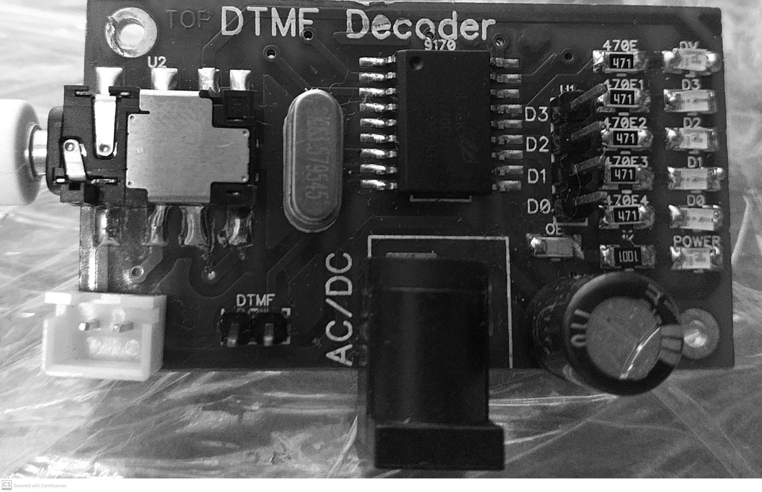

**7.0 Skill Developed/Learning out of this Micro Project** (In about 150 to 300 words)

* Using Fritzing software
* PCB designing
* Circuit analysis

Annexure-IIA

**Department of Electronics and Telecommunication Engineering**

**Name of Student: Sania Bandekar** **Enrollment No: 17201B0022**

**Name of Programme:** **Semester: 5th**

**Course Title:** **Code:**

**Title of the Micro Project:** **DTMF Decoder**

**Course Outcomes Achieved:**

**Micro Project Evaluation Sheet**

|  |  |  |  |  |
| --- | --- | --- | --- | --- |
| **Process Assessment** | | **Product Assessment** | | **Total** |
| **Part-A** | **Project** | **Part-B** | **Individual** | **Marks 10** |
| **Project Proposal** | **Methodology** | **Project Report/** | **Presentation/** |  |
| **(Mark-2)** | **(Mark-2)** | **Working Model** | **Viva** |  |
|  |  | **(Marks-2)** | **(Marks-4)** |  |
|  |  |  |  |  |

**Note: Every course teacher is expected to assign marks for group evolution in first 3 columns and individual in 4th columns for each group of students as per rubrics.**

**Comments/Suggestions about team work/leadership/inter-personal communication (if any)**

**----------------------------------------------------------------------------------------------------------------------------**

**----------------------------------------------------------------------------------------------------------------------------**

**Any other Comments:**

**----------------------------------------------------------------------------------------------------------------------------**

**----------------------------------------------------------------------------------------------------------------------------**

**Name and Designation of Faculty Members**

**Signature:**